**Test Automation – Assignment III**

**Application to be tested - URL:**

https://www.myntra.com

**Instructions:**

* Use different locators
* Include Assert statements
* If any of the steps is missing for the test scenario, you can pick alternate step/scenario from the same website and proceed with the automation
* Use Chrome Browser
* Include Time delays ( sleep/implicit/explicit) wherever needed

**Tasks:**

* Go to myntra.com

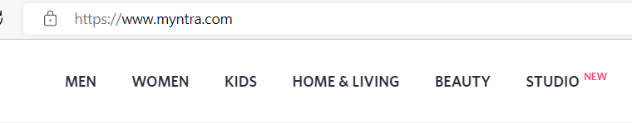

* Enter “Bluetooth headphones” in searchbox 
* Click Search button
* Select “whats new”

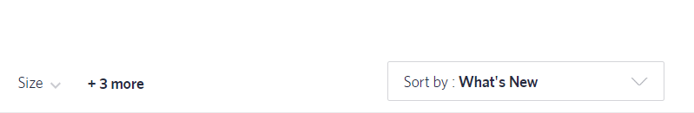

Select brand as JBL

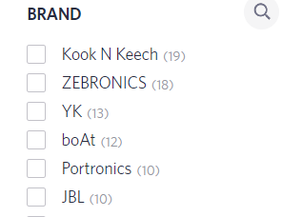

Validate if the item displayed at the top has brand name as JBL in it.

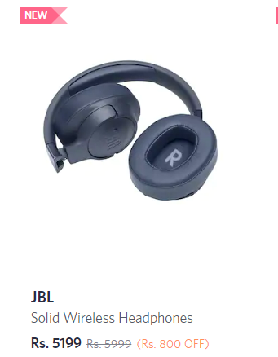

**Refer screenshot for each step**